1. difference between add and copy Docker file….?

ADD and COPY are two similar Dockerfile instructions which let you add content to your images at build time. Whereas**COPY is a straightforward source to destination copy, ADD includes extra functionality for working with archives and remote URLs**.

download application url by using ADD

1. What is the difference between Entrypoint and CMD….?

**ENTRYPOINT** should be defined when using the container as an executable. **CMD** should be used as a way of defining default arguments for an ENTRYPOINT command or for executing an ad-hoc command in a container. **CMD** will be overridden when running the container with alternative arguments.

**ENTRYPOINT** wont be overridden when running the container with alternative arguments.

1. What is the overlay network in docker swarm…?

The overlay network driver creates a**distributed network that can span multiple docker hosts**. Overlay networks were designed to be used with docker swarm services. Docker swarm is a container orchestration tool (like Kubernetes) that allows us to manage multiple containers on multiple hosts.

4. **What is the difference between ConfigMaps and secrets in Kubernetes & docker swarm…?**

Kubernetes offers different kinds of secrets for specific use cases. The primary difference between these two is that while ConfigMaps are designed to store any type of non-sensitive application data,

Secrets are designed to store sensitive application data such as passwords, tokens, etc.

5. What is the difference between diff blue green deployment & canary?

While Blue/green deployments are used to**eliminate downtime**, Canary deployments are used to test a new feature in a production environment with minimal risk. The argument on Canary deployment vs blue-green is never-ending.

6.how to check log  container ? wt is command using docker ?

docker logs containername or container id

7.how to remove the images?

docker rmi container id

8.how to login to the container?

docker exec -it container id bash

9.docker to running container?

docker ps

10.how to check images ?

docker images

11.wt is command using for running container?

docker run --rm -dit --name NGINX --hostname NGINX01 -p 8000:80 docker repository:tagname

12.can you please tell write docker file ?

nano Dockerfile

FROM ubuntu:18.04

RUN apt update

RUN apt install -y nginx

RUN apt install -y jq

Docker build -t docker repository:tagname

Above using for build the images?

Wt is diff between virulization & docker?

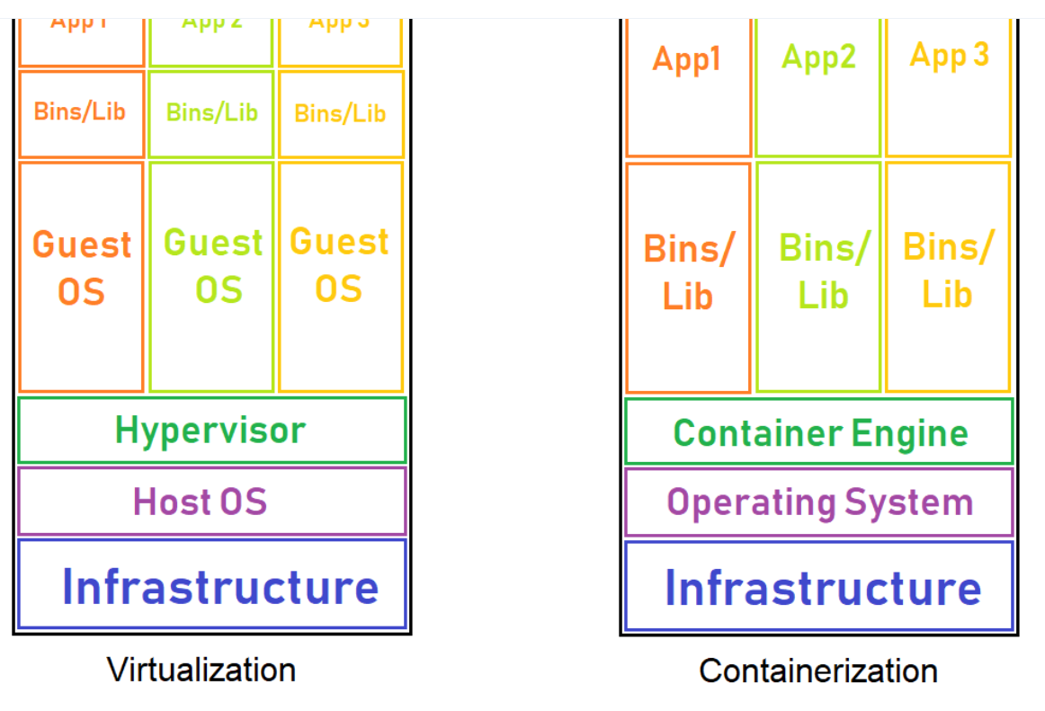

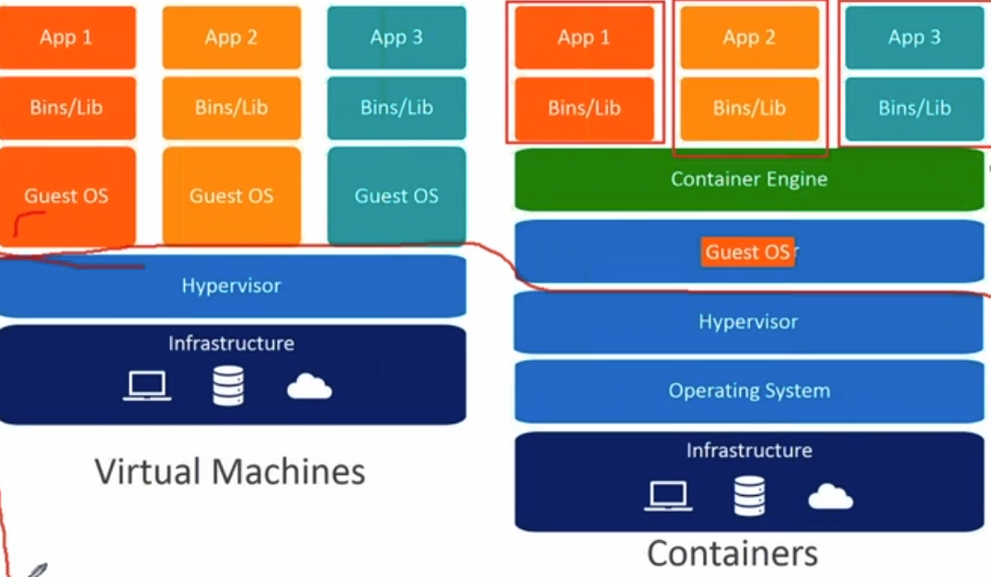

we have region & set of az is called region &az is called data centers & set of rackes include in data center &in the rack physical servers running &on the top of the physical server hypervision installed for support virtual machine & on the hypervisior running guest os like linux and ubuntu and on the top guest os container engine layer running & application related library install in bins/lib and the application running

virtual machine

first hardware

on top of the hardware hypervisor

on top of the hypervisotor  GUEST OS

on top of the hypervisotor  APPLICATION

container

first hardware

on top of the hardware CONTAINER ENGINE

on top of the hypervisotor  APPLICATION

13.wt are type of docker volumes?

[Volumes | Docker Documentation](https://docs.docker.com/storage/volumes/)

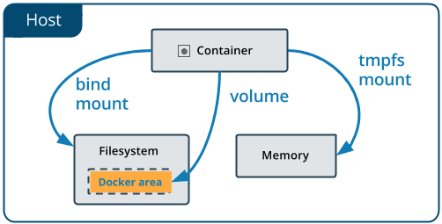

**Volumes**

Volumes are the preferred mechanism for persisting data generated by and used by Docker containers. While [bind mounts](https://docs.docker.com/storage/bind-mounts/) are dependent on the directory structure and OS of the host machine, volumes are completely managed by Docker. Volumes have several advantages over bind mounts:

* Volumes are easier to back up or migrate than bind mounts.
* You can manage volumes using Docker CLI commands or the Docker API.
* Volumes work on both Linux and Windows containers.
* Volumes can be more safely shared among multiple containers.
* Volume drivers let you store volumes on remote hosts or cloud providers, to encrypt the contents of volumes, or to add other functionality.
* New volumes can have their content pre-populated by a container.
* Volumes on Docker Desktop have much higher performance than bind mounts from Mac and Windows hosts.

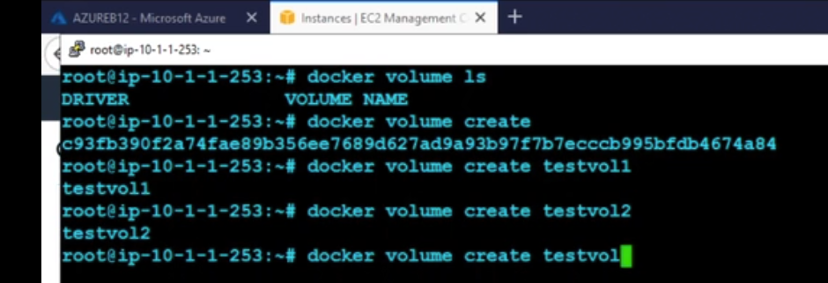

14. how to remove the volume?&how to volume wt is command?

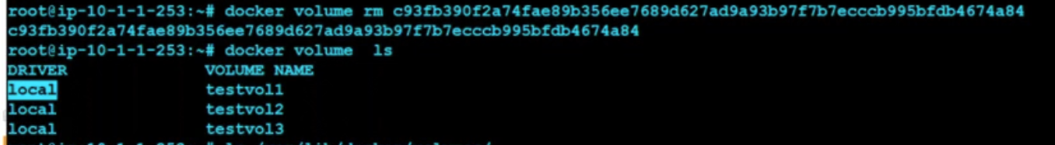

15.where volumes is docker?

**How to use a volume in docker?**

To create a Docker Volume use the command: docker volume create [volume_name] Docker automatically creates a directory for the volume on the host under the /var/lib/docker/volume/ path. You can now mount this volume on a container, ensuring data persistence and data sharing among multiple containers.

Volumes is stored var/lib/docker/volumes



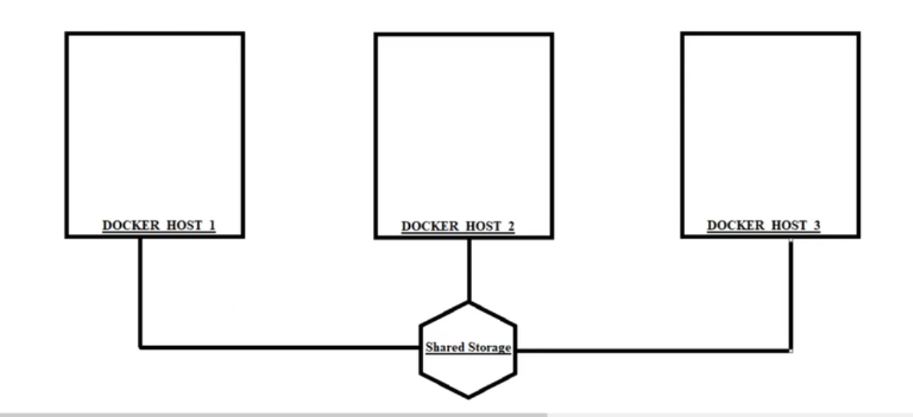



16.wt is prune using docker?

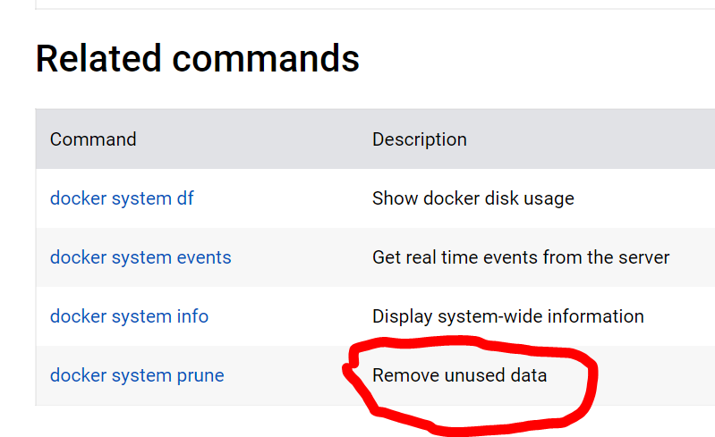

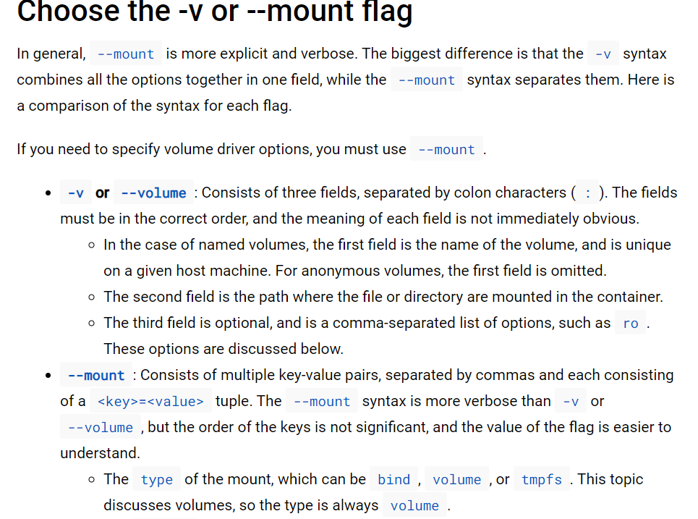

17.wt are the docker networker?

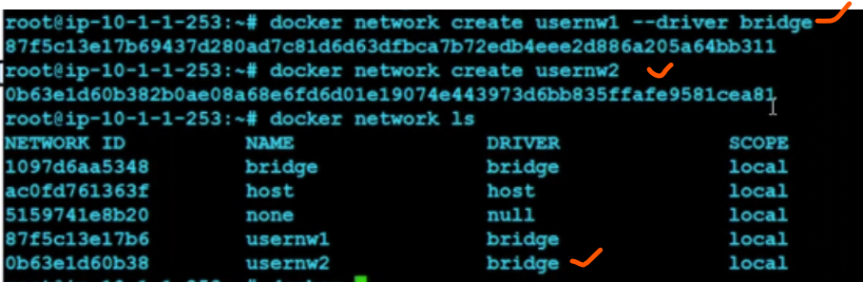

18.docker is overlay network & bridge network?

**Bridge networks can be created for single host and overlay networks can be created for multiple hosts**

**19.wt is docker host network?**

**What is a host in Docker?**

In Docker, the host is a machine responsible for running one or more containers. Docker network host, also known as Docker host networking, is a networking mode in which a Docker container shares its network namespace with the host machine. The application inside the container can be accessed using a port at the host's IP address (e.g., port 80).

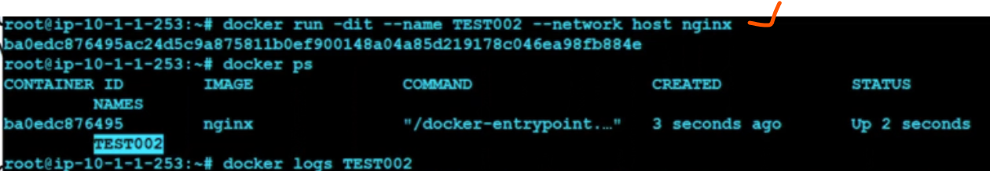

20.how to get information of conatainer?

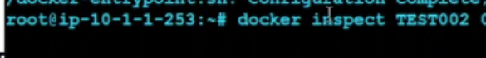

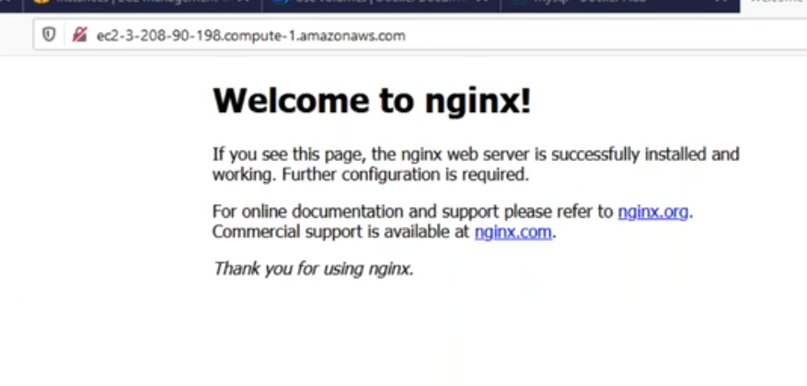

Host network in docker actually using host ip adresss of server that why communicate with container

21.how to check information network



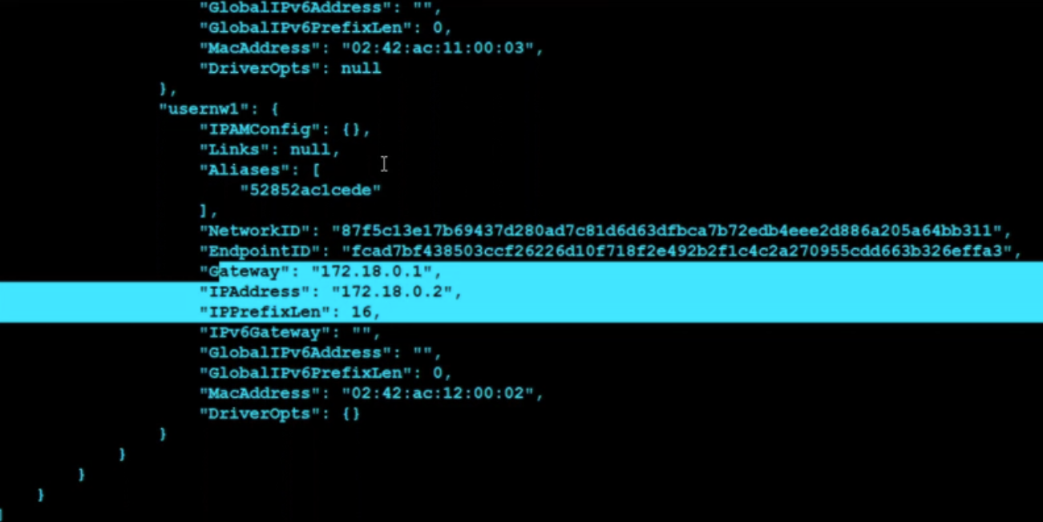

22.how to check the contianer log?

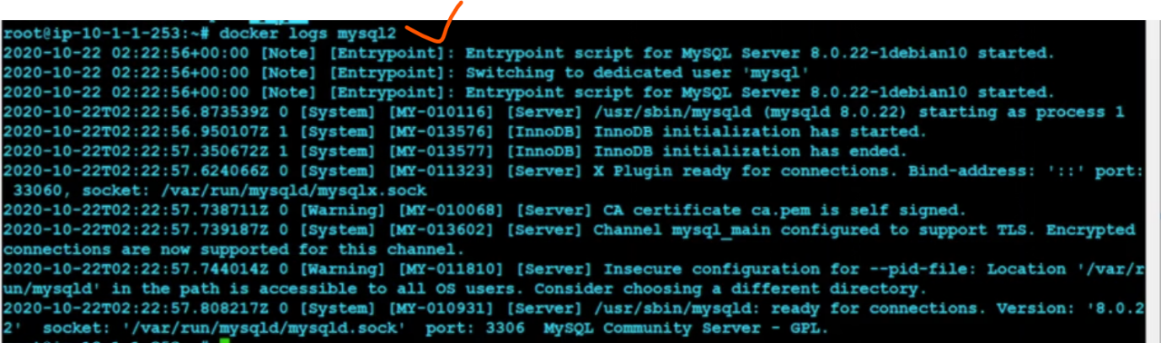

23.How to check the container inf?



24.wt is expose?

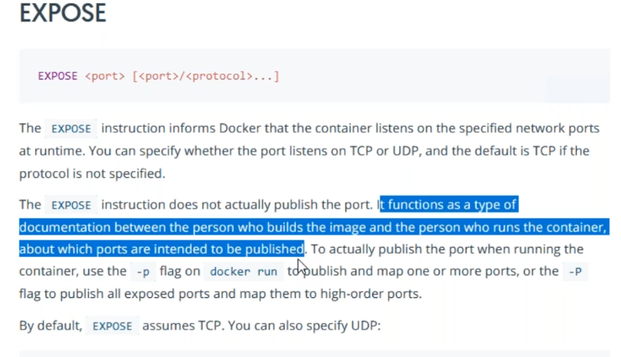

25.wt is registory vs repository in docker?

While **a container repository is a collection of related container images used to manage, pull and push images, a container registry is a collection of repositories made to store container images**. Container registries can store container images as well as API paths and access control rules.

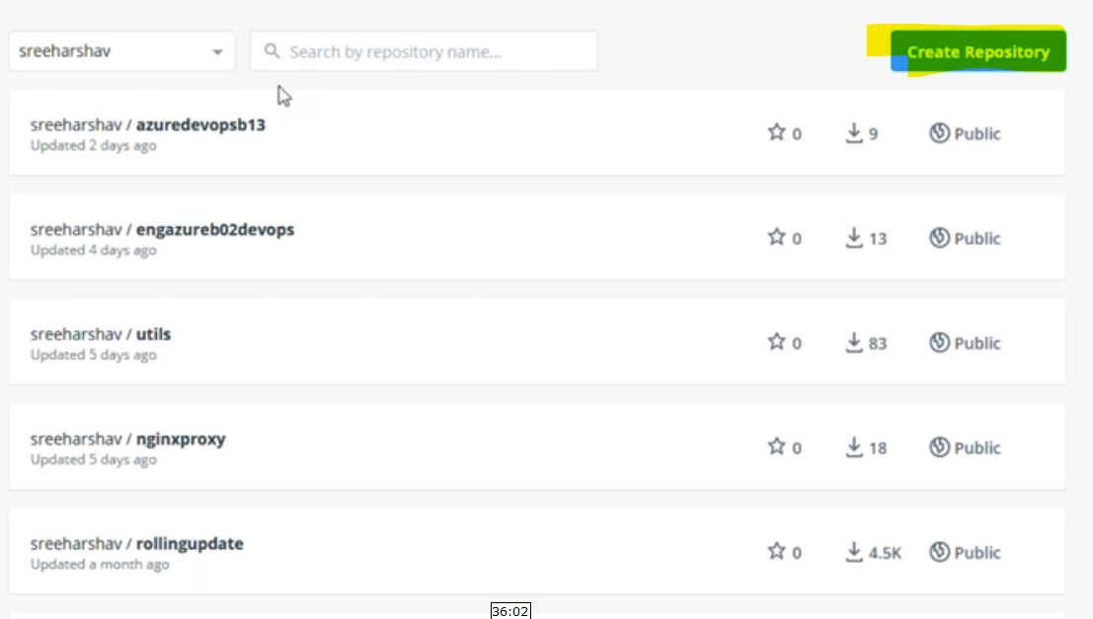

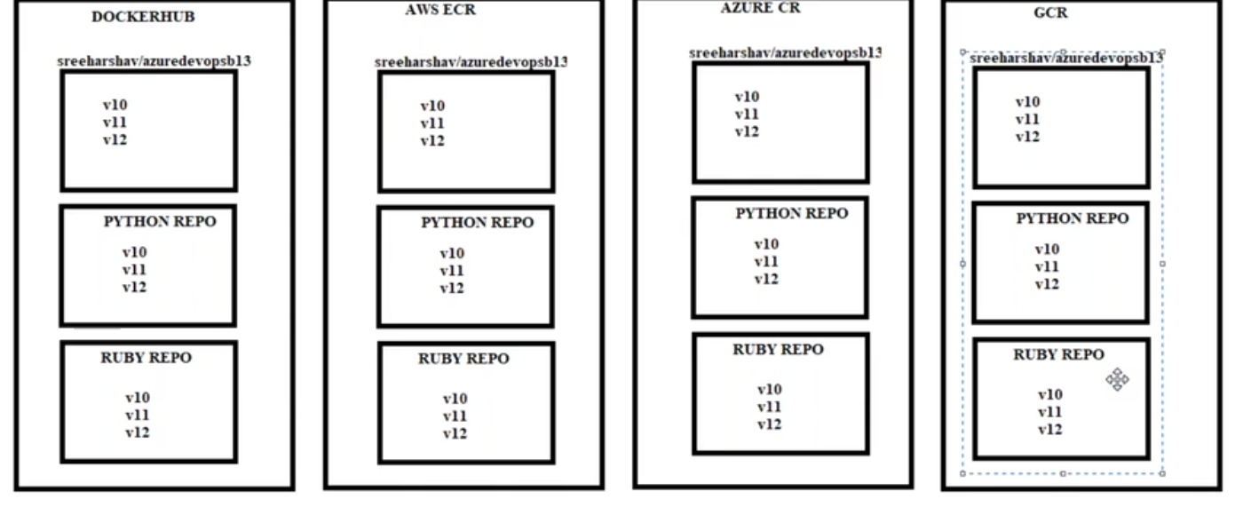

26. wt is diff between internal & external port?

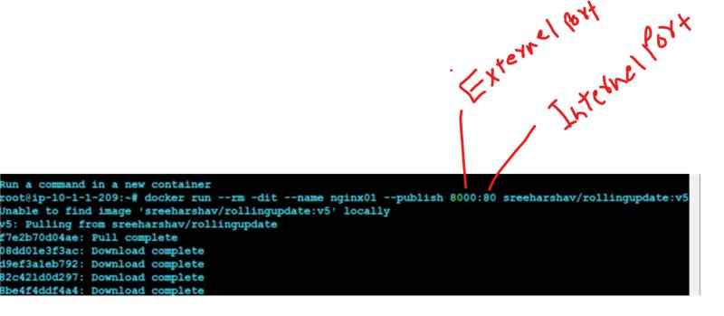

below diagram internal port 80

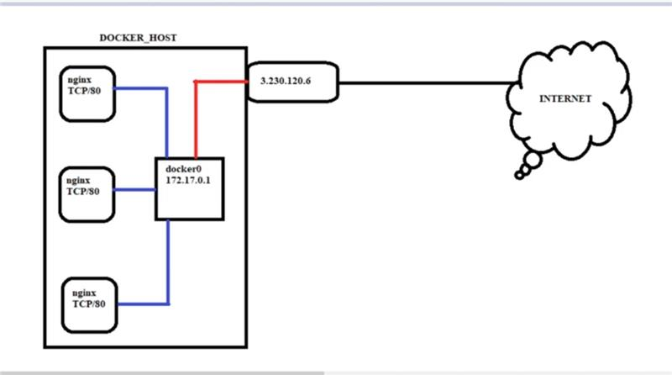

port forwarding port for backed  support like 8000

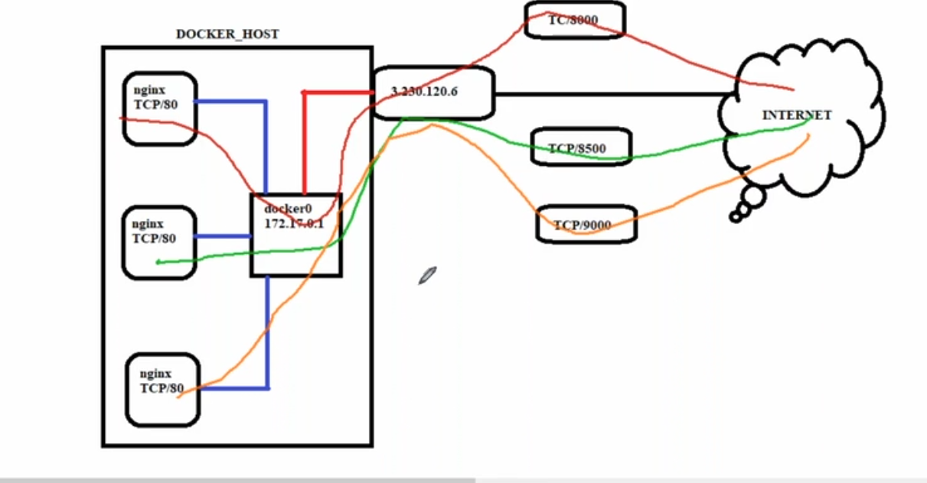

27.wt is diff between the docker push & docker pull?

What is Docker push used for?

Description. Use docker image push **to share your images to the Docker Hub registry or to a self-hosted one**

docker pull the images from docker registry like docker  hub and elastic container registry

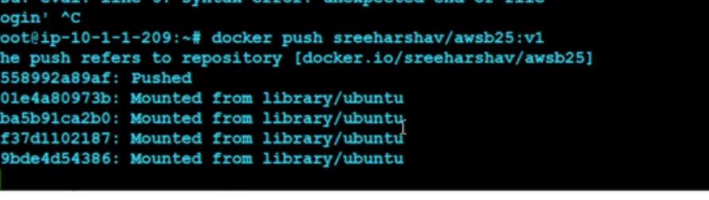

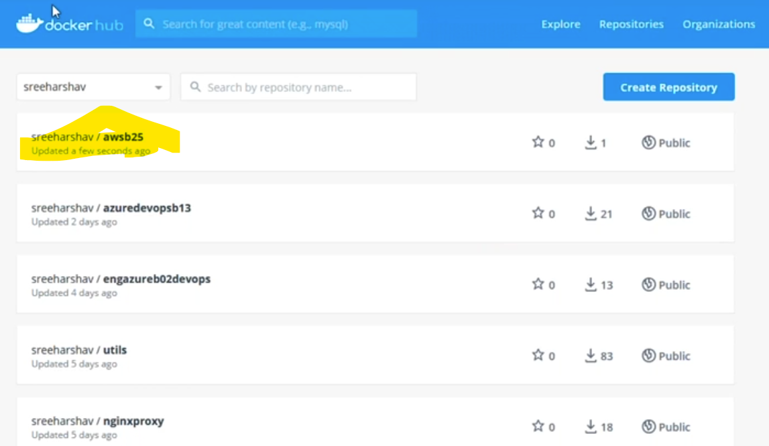

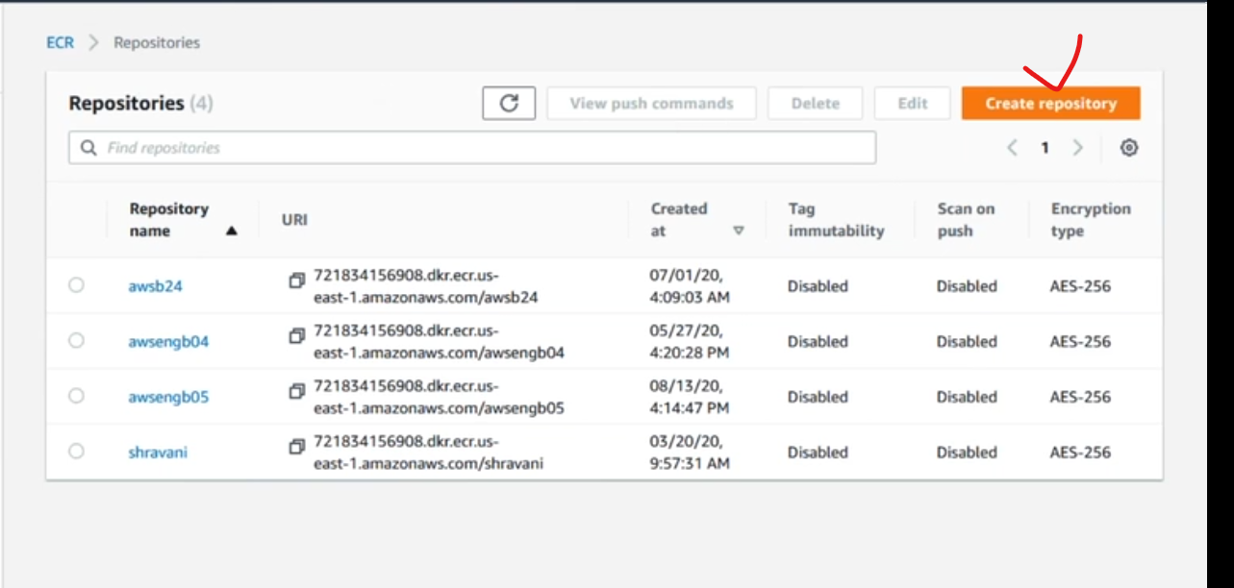

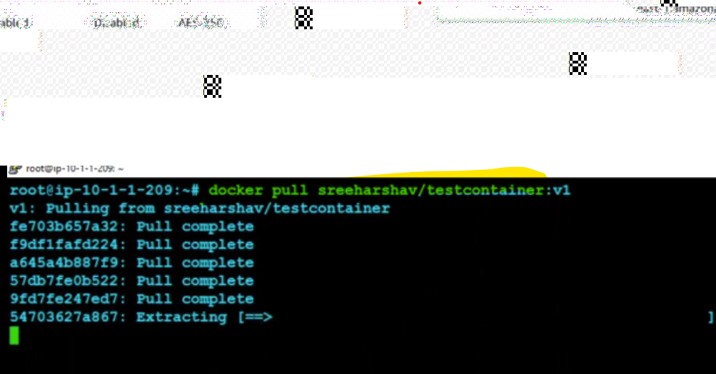



28.wt is diff ecs & fargate in aws?

If you need auto-scaling or run containers in a serverless environment, then Fargate is the right choice. But, **ECS is better if you need more flexibility or are on a budget**. Overall, both services are excellent choices for running containers in AWS. It just comes down to your specific needs and preference

29. Docker Container possible States…?

 Docker Container can be in one of four states 1. RUNNING STATE

                                                                           2. PAUSED STATE

                                                                           3. EXITED STATE

                                                                           4. RESTARTING STATE

30. what is the diff b/w VM & Docker Container....?

Ans:- Containers are very less & Light Weight and come to the VMs are running in More space & Memory so the system becomes Slow so that's the Major diff b/w Container and VMs...